**Week 5**

**Hands-on Guide: Creating Microservices for Account and Loan**

**Scenario:** You need to create two independent Spring RESTful Web Service Maven projects: one for handling accounts and one for handling loans. These services will initially not have backend connectivity and will return dummy responses.

**Goal:**

1. Set up two separate Spring Boot microservices.
2. Implement a simple GET endpoint for each.
3. Understand and resolve port conflicts when running multiple microservices locally.

***Account Microservice***

***AccountController.java:***

**package** com.cognizant.account.controller;

**import** org.springframework.web.bind.annotation.GetMapping;

**import** org.springframework.web.bind.annotation.PathVariable;

**import** org.springframework.web.bind.annotation.RestController;

**import** org.slf4j.Logger;

**import** org.slf4j.LoggerFactory;

**import** java.util.HashMap;

**import** java.util.Map;

@RestController

**public** **class** AccountController {

**private** **static** **final** Logger ***LOGGER*** = LoggerFactory.*getLogger*(AccountController.**class**);

@GetMapping("/accounts/{number}")

**public** Map<String, Object> getAccountDetails(@PathVariable("number") String number) {

***LOGGER***.info("START - getAccountDetails() for account number: {}", number);

Map<String, Object> accountDetails = **new** HashMap<>();

accountDetails.put("number", number);

accountDetails.put("type", "savings");

accountDetails.put("balance", 234343);

***LOGGER***.info("END - getAccountDetails(). Returning: {}", accountDetails);

**return** accountDetails;

}

}

***AccountApplication.java:***

**package** com.cognizant.account;

**import** org.springframework.boot.SpringApplication;

**import** org.springframework.boot.autoconfigure.SpringBootApplication;

@SpringBootApplication

**public** **class** AccountApplication {

**public** **static** **void** main(String[] args) {

SpringApplication.run(AccountApplication.**class**, args);

}

}

***Output:***  
 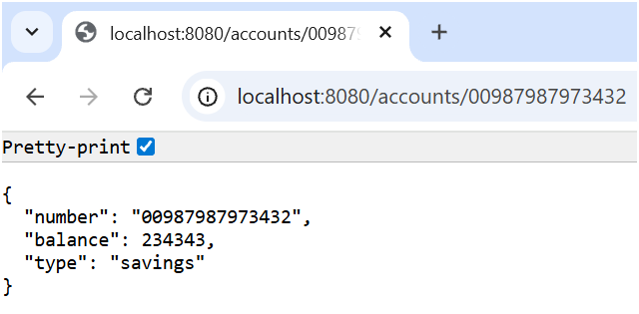

***Loan Microservice***

***LoanController.java:***

**package** com.cognizant.loan.controller;

**import** org.springframework.web.bind.annotation.GetMapping;

**import** org.springframework.web.bind.annotation.PathVariable;

**import** org.springframework.web.bind.annotation.RestController;

**import** org.slf4j.Logger;

**import** org.slf4j.LoggerFactory;

**import** java.util.HashMap;

**import** java.util.Map;

@RestController

**public** **class** LoanController {

**private** **static** **final** Logger ***LOGGER*** = LoggerFactory.*getLogger*(LoanController.**class**);

@GetMapping("/loans/{number}")

**public** Map<String, Object> getLoanDetails(@PathVariable("number") String number) {

***LOGGER***.info("START - getLoanDetails() for loan number: {}", number);

Map<String, Object> loanDetails = **new** HashMap<>();

loanDetails.put("number", number);

loanDetails.put("type", "car");

loanDetails.put("loan", 400000);

loanDetails.put("emi", 3258);

loanDetails.put("tenure", 18);

***LOGGER***.info("END - getLoanDetails(). Returning: {}", loanDetails);

**return** loanDetails;

}

}

***Output:***

